Media alert
AMAZON’S PERTH TEAM DON THEIR FAVOURITE PJS IN SUPPORT OF KIDS BATTLING CANCER
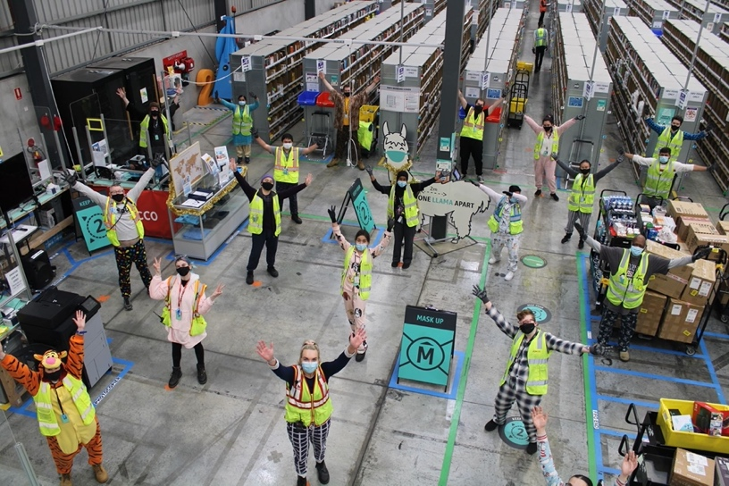

PERTH, 16 September 2021 – This week the team at Amazon Australia’s Perth fulfilment centre wore their pyjamas to work as part of the annual Amazon Goes Gold (AGG) PJammin’ initiative to raise awareness and funds for pediatric cancer.

In addition to donning their finest pyjamas in solidarity with the hundreds of Australian children that are diagnosed with cancer each year, Amazon Australia donated $45,000 to Perth Children’s Hospital Foundation and provided activity bags with handwritten notes from the team to entertain the kids who are currently in the oncology ward.

Sanda, Inbound Stow Assistant at Amazon Australia said, “While somewhat of a novelty to wear our PJs to work, the reality is that it is no joke for the thousands of Australians fighting cancer everyday from their hospital beds. I feel privileged to raise funds for children’s cancer alongside my colleagues and I’m incredibly proud to be part of a team that is making a difference.”

In Australia alone, over 750 children between the ages of 0-14 are diagnosed with cancer each year¹ and it is one of the leading cause of death by disease among children in many countries. This year Amazon Australia will donate more than $100,000 to fund children’s cancer research and support programs at children’s hospitals near its operational sites in Australia as part of its Amazon Goes Gold initiative.

Carrick Robinson, CEO of Perth Children’s Hospital Foundation said, “Perth Children’s Hospital Foundation is proud to support research trials, equipment and world-class clinicians and researchers leading the charge to improve survival rates and treatment side effects for 100 children with diagnosed with cancer in WA each year. Thanks to our generous donors like Amazon, we will help reduce suffering for children and their families and change global practice”.

Craig Fuller, Director of Operations at Amazon Australia said, “Over the past 18 months, pyjamas may have increasingly made their way into our virtual offices as many of us have adjusted to working from home, but it’s important to remember that for years this has been the battle uniform of kids fighting cancer during their treatment and recovery.

“At Amazon, we’re proud to be wearing our pyjamas at our facilities across the country to stand in unity with these children and their families. We hope to not only raise much needed funds and awareness, but also shine a spotlight on the incredible work that is being done by so many organisations to increase survival rates and find cures for childhood cancer.”

#AmazonGoesGold is a global initiative, spanning North America, Europe, Middle East the U.K. and Australia, to bring greater awareness to childhood cancer globally, and partner with local hospitals and organisations where Amazon employees work and live.
– ends –

About Amazon
Amazon is guided by four principles: customer obsession rather than competitor focus, passion for invention, commitment to operational excellence, and long-term thinking. Amazon strives to be Earth’s Most Customer-Centric Company, Earth’s Best Employer, and Earth’s Safest Place to Work. Customer reviews, 1-Click shopping, personalized recommendations, Prime, Fulfillment by Amazon, AWS, Kindle Direct Publishing, Kindle, Career Choice, Fire tablets, Fire TV, Amazon Echo, Alexa, Just Walk Out technology, Amazon Studios, and The Climate Pledge are some of the things pioneered by Amazon. For more information, visit amazon.com/about and follow @AmazonNews.

¹https://www.cancer.org.au/cancer-information/types-of-cancer/childhood-cancers/cancer-council-and-childhood-cancers

